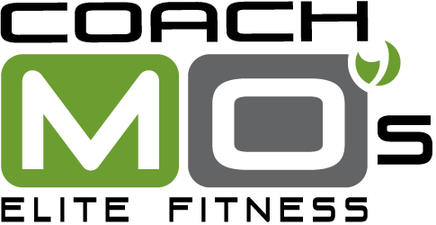

Summer 2024
Youth Small Group Strength Training Camp
Registration Form

To complete registration:

⬜ SELECT WEEK (CHECK SELECTION):

__ JUNE 3rd -JUNE 6th

__ JUNE 10th - JUNE 13th

__ July 22nd -25th

Cost: $250 for Week
Time : 3pm- 4:30pm

⬜ Complete and email this form to maurice@coachmofitness.com or mail or submit the form in person to Coach Mo's Elite Fitness, 7119 Chimney Corners, Austin, TX 78731.

Select payment method:
⬜ I have a credit/debit card on file with Coach Mo’s. Please bill to my card on file.
⬜ I submitted payment online.

Athlete’s Name: ________________________________________________________ Age: _______

Athlete’s Name: ________________________________________________________ Age: _______
Home Address: ____________________________________City: _____________ ZIP: ___________
Parent(s) name(s): _________________________________________________________________
Parent(s) phone number(s): __________________________________________________________
Email (to confirm registration): ________________________________________________________
Emergency contact name and phone: ___________________________________________________

PLEASE READ AND SIGN THE RELEASE WAIVER ON THE NEXT PAGE

Coach Mo’s Elite Fitness
WAIVER AND RELEASE OF LIABILITY

I ACKNOWLEDGE THAT BY SIGNING THIS DOCUMENT, I AM RELEASING Coach Mo’s Elite Fitness AND ITS RESPECTIVE TRAINERS, CONTRACTORS, OWNERS, OFFICERS, EMPLOYEES, REPRESENTATIVES, AGENTS, VOLUNTEERS, AFFILIATES, AND/OR ANYONE ACTING FOR OR ON BEHALF OF ANY OF THEM (COLLECTIVELY “RELEASED PARTIES”) FROM ANY AND ALL CLAIMS, DAMAGES AND LIABILITY RELATED TO MY PARTICIPATION IN THE ACTIVITIES. THIS RELEASE IS A CONTRACT WITH LEGAL CONSEQUENCES. I HAVE BEEN ADVISED TO READ IT CAREFULLY BEFORE SIGNING.
[The following provision must be signed by parent or guardian if participant is under 18 years old]
I am the parent or guardian of ______ ____________________ (child/children).
My Child does not have any known health, physical or medical conditions that would endanger my Child or others and is fit to participate in the activities, and I consent to my Child’s participation. I HAVE READ AND I UNDERSTAND THE ABOVE RELEASE AND WAIVER AGREEMENT. In consideration of allowing my Child to participate, I consent to and agree that THE TERMS SHALL LIKEWISE BIND ME, MY CHILD, and our heirs, legal representatives, and assignees. I HEREBY RELEASE, DISCHARGE AND SHALL DEFEND, INDEMNIFY AND HOLD HARMLESS THE RELEASED PARTIES FROM EVERY CLAIM, DAMAGE, LOSS AND ANY LIABILITY that I or my Child may allege against the Released Parties (including reasonable attorney’s fees or costs) as a direct or indirect result of injury to me or my Child because of my Child’s participation in the activities, WHETHER CAUSED BY NEGLIGENCE OF THE RELEASED PARTIES or others. I PROMISE NOT TO SUE THE RELEASED PARTIES on my behalf or in behalf of my Child regarding any claim arising from my Child’s participation in the activities. Photo and Video release: In connection with my participation in Coach Mo’s Elite Fitness, Inc., programs, I consent to the use of my child’s/children’s photograph and video or other likeness in the promotional and other materials of Coach Mo’s Elite Fitness without payment or other consideration made to me.

Name (Print): _______________________________________ Date: ___________________________
Parent Signature: Phone: ________________________

